**TC_Login Valid** (TC-001)

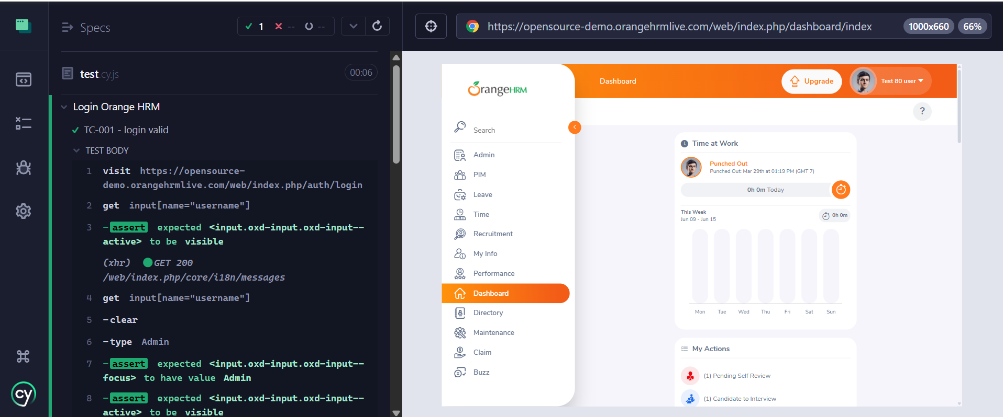

**TC_Login Invalid Pass** (TC-002)

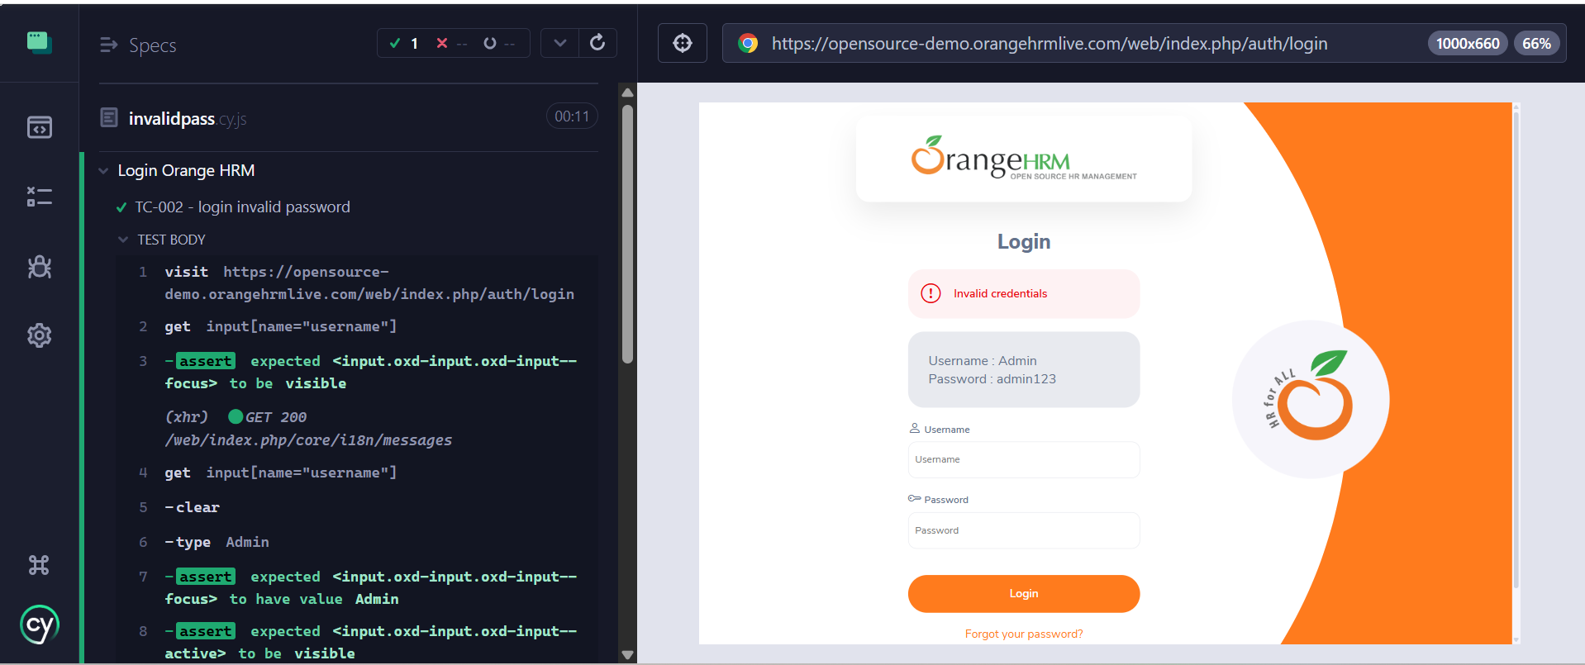

**TC_ Login Invalid Username** (TC-003)

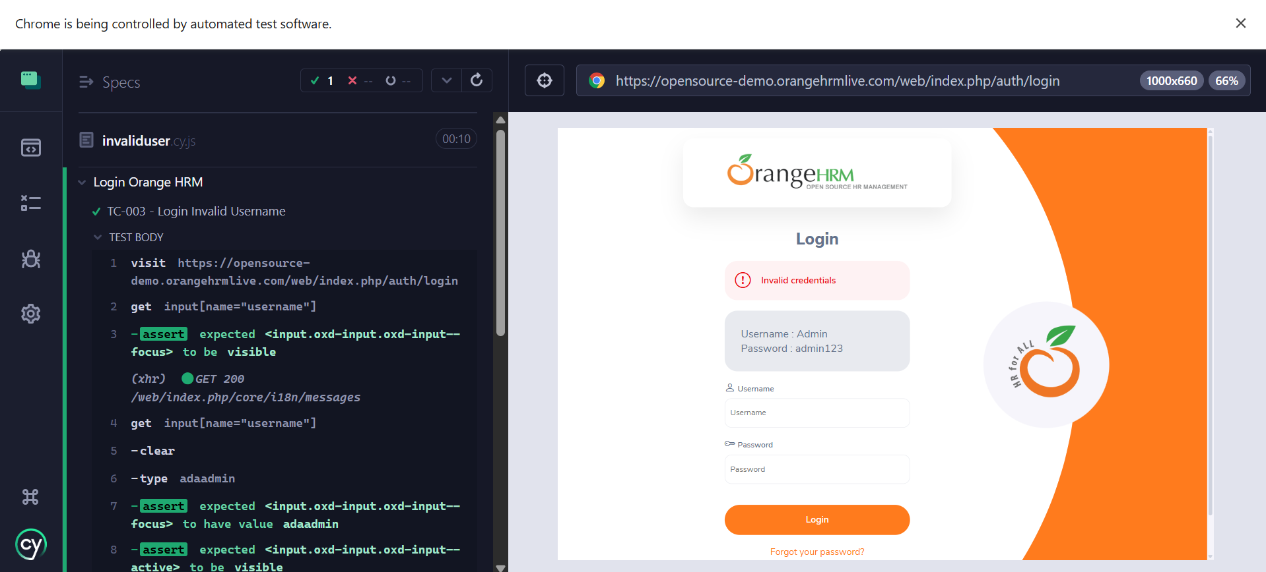

**TC_ Login Empty Field** (TC-004)

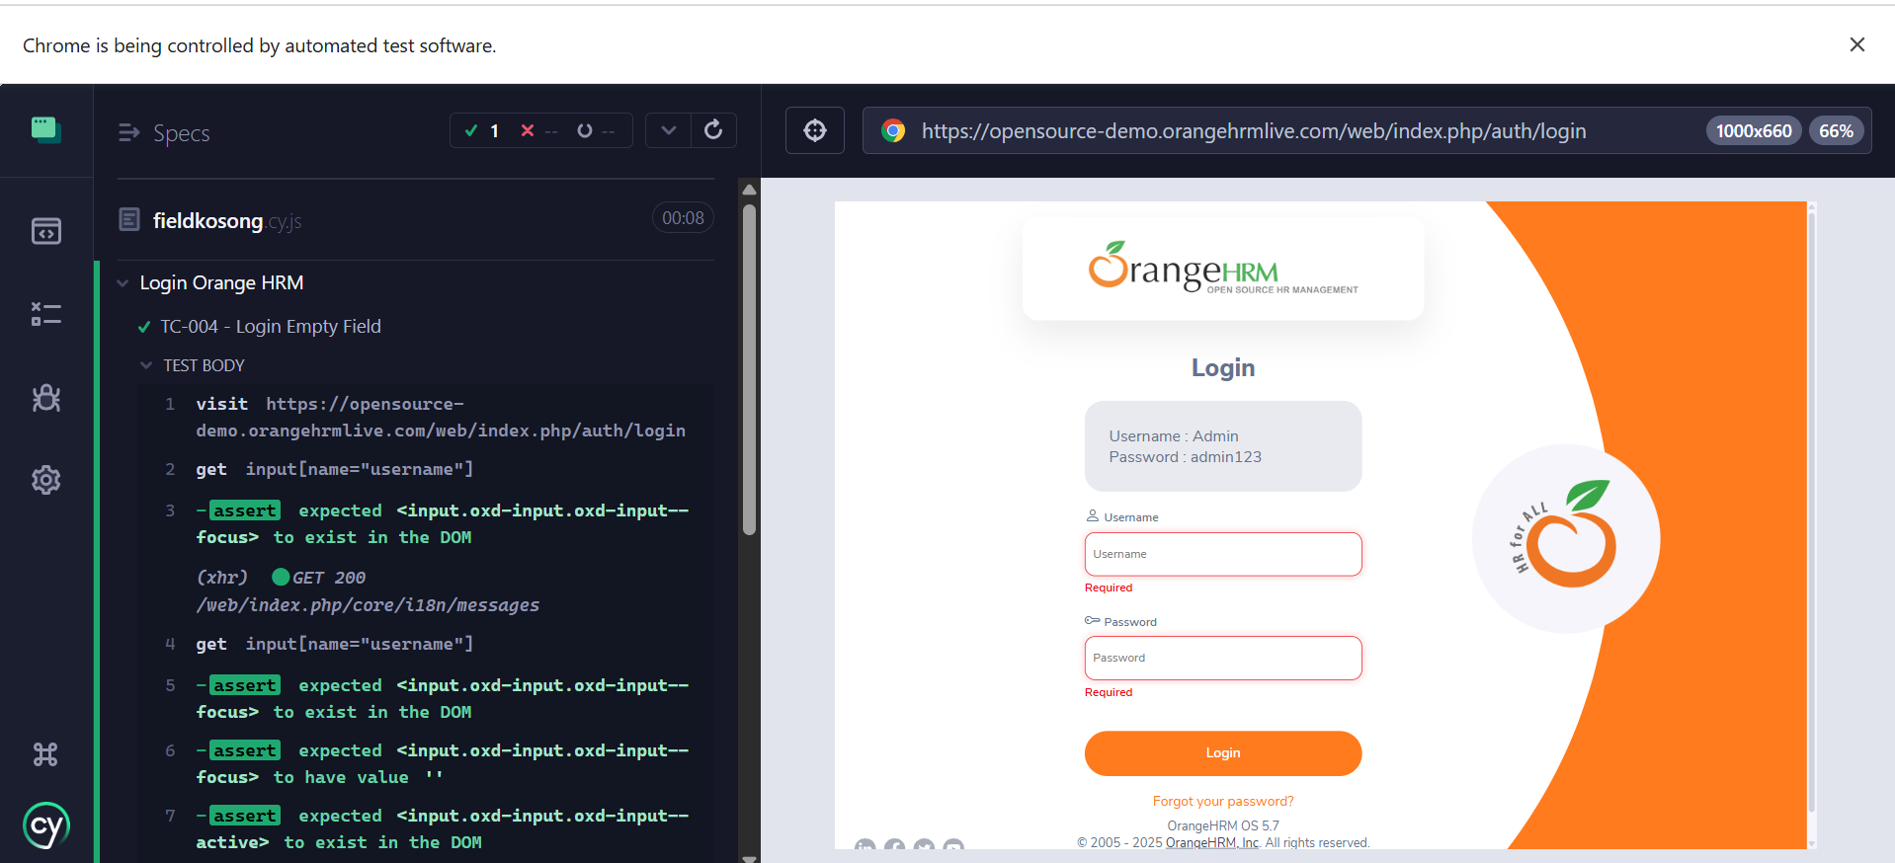

**TC_ Login Invalid Characters** (TC-005)

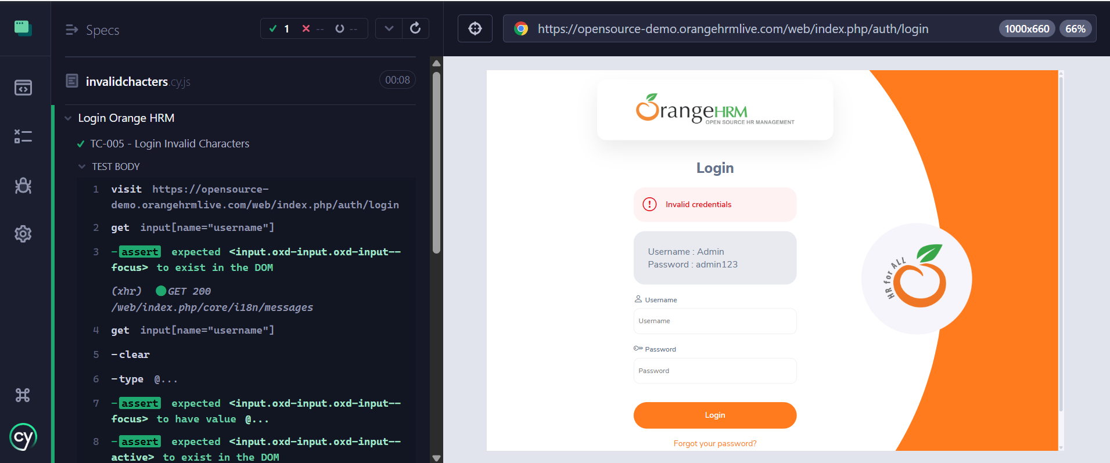

**TC_ Login Button Visibility** (TC-006)

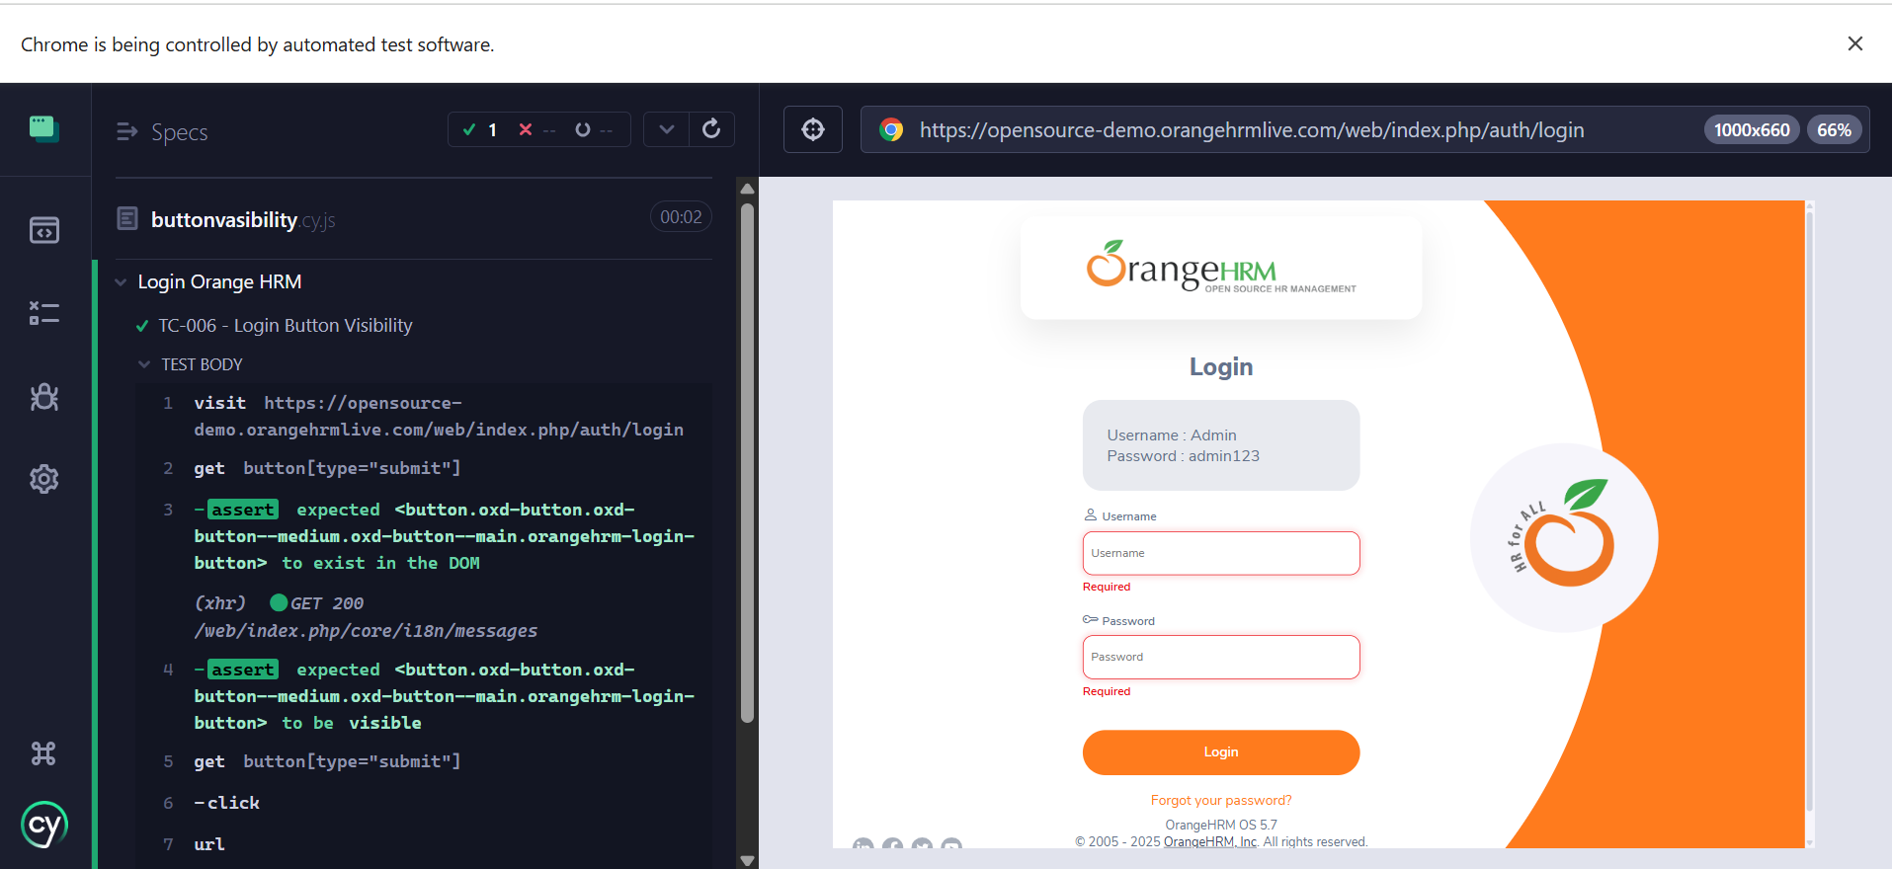

**TC_ Forgot Password** (TC-007)

